**-Dimenzije nasadila**

|  |  |
| --- | --- |
| Art | T-1016 |
| A | 16 |
| B | 66 |
| C | 8 |
| D | 66 |
| Ef | 8,5 |
| Em1 | M 10x1 |
| Em2 | 10 |
| Ff | 40 |
| Fm1 | 27 |
| Fm2 | 65 |
| G | 26 |

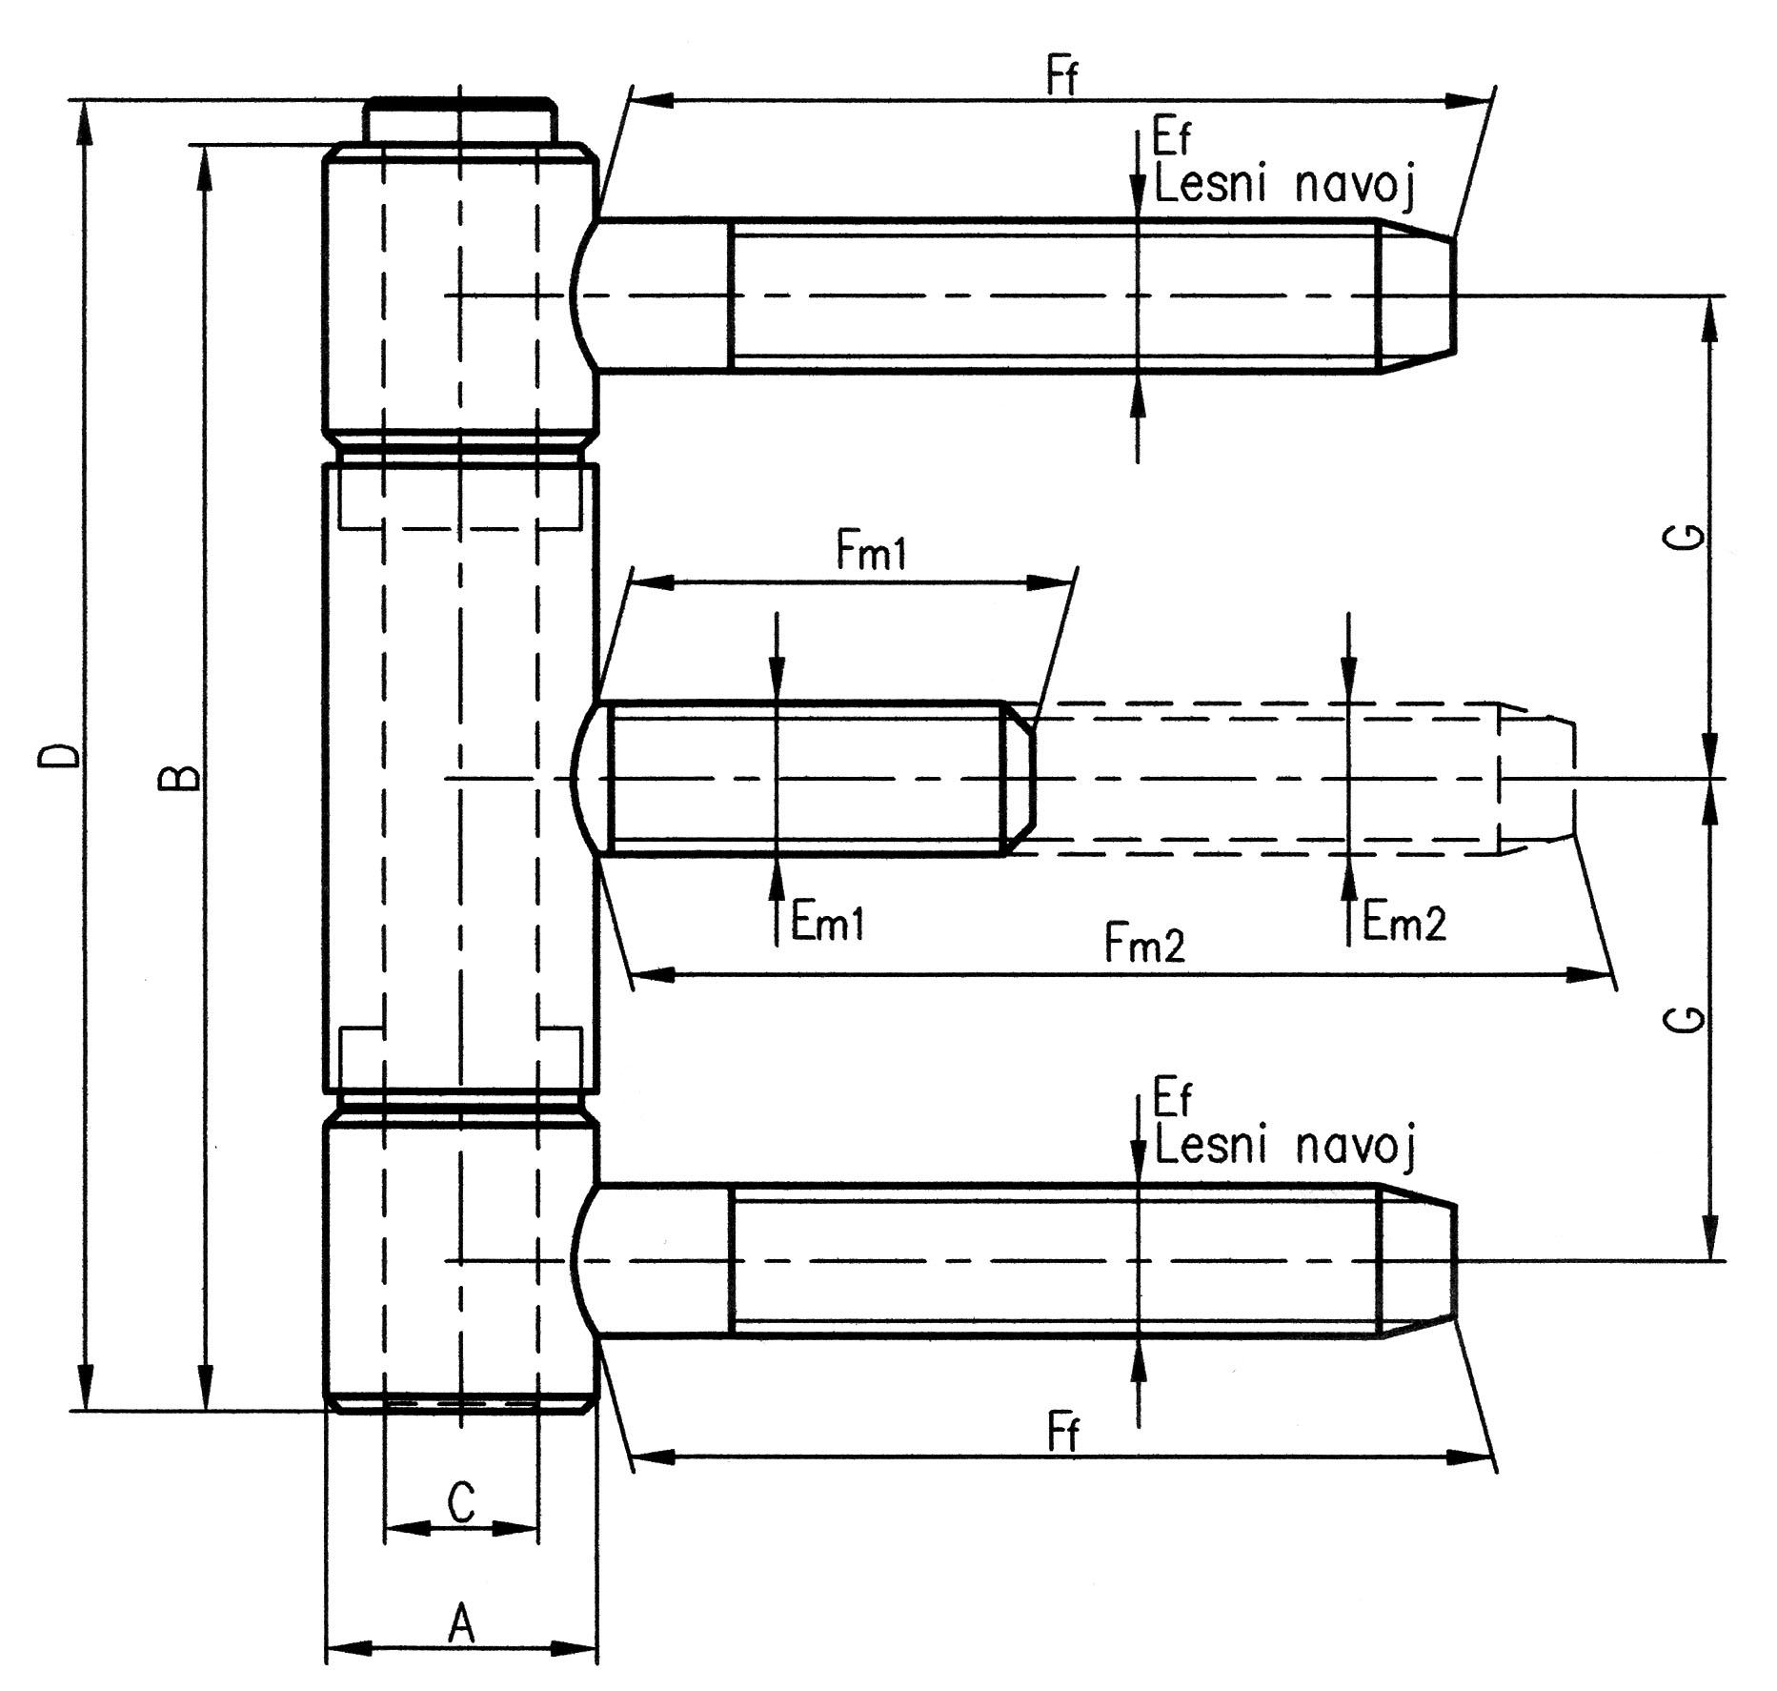

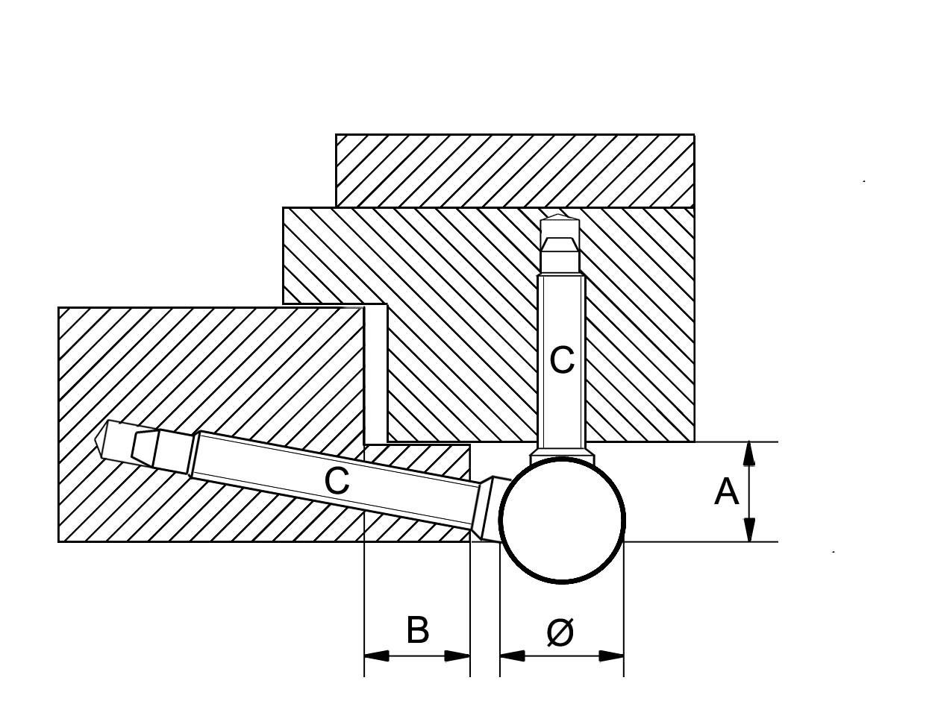

**-Montažne mere**

|  |  |  |  |  |
| --- | --- | --- | --- | --- |
| Tip | Ø | A | B | C |
| 1016 | 16 | 15 | 14 | 9,4 |